**Quick Note on Azure Boards**

There was an issue which students faced when they could not see user stories when creating work items. They would only be able to see Epic, issue and Task as shown below

This depends on what Azure DevOps chooses as the default process for the project. It might be choosing the Basic Work item process for the project.

To get user stories for the work items , when creating the project , to the Advanced section and choose Agile as the work item process.

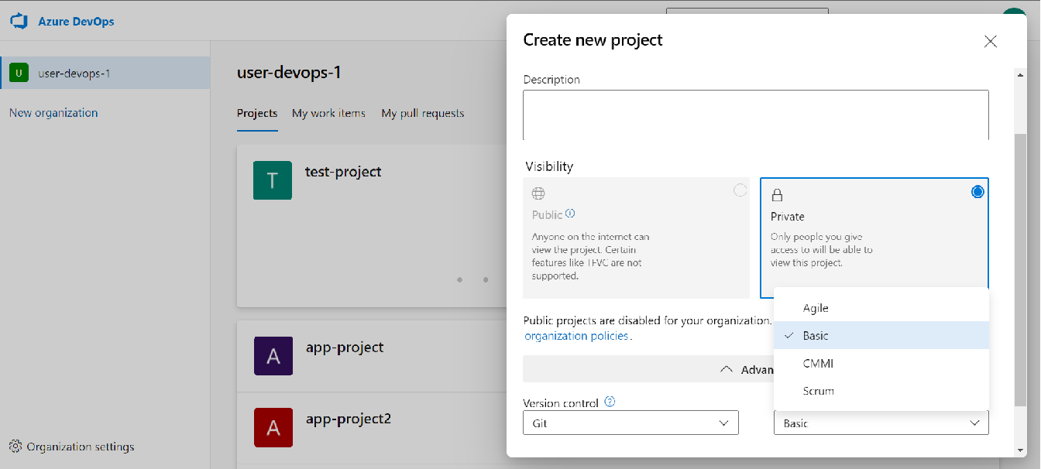

Once you choose the Agile process, and then when you go to Azure Boards, you can then create User stories

